# **Storing Application logs in Evidence Vault**

## **Summary**

As a HPP product compliance, HPP application logs should be stored for 6 years. Application logs and server side performance counters are stored in Log Analytics Workspace in Azure Subscription.

UploadApplicationLogsToEvidenceVault.exe is a custom program developed to download application logs from Log analytics and to upload in Evidence Vaults.

## **Design**

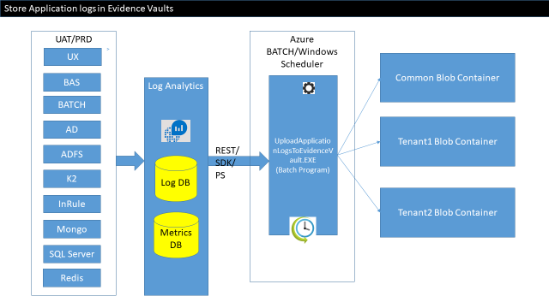

## **Evidence Vaults**

Evidence Vaults are basically Azure Storage Account where logs and other compliance related artifacts are stored in Blob Containers. All Evidence Vaults can be found on hpp-security-and-compliance resource groups.

## **Code**

**C:\ua3\Source\Utilities\Dev\UploadLogsToEV**

## **TenantConfig.json**

{

"EnvironmentName": "UAT",

"SharedResourceGroupName": "hpp_prd_rgp_app_001",

"sharedStorageconnectionstring": "XXXXXXXX",

"sharedBlobContainerName": "logs",

"hppTenants": [

{

"hppTenantID": "ece8ada4-4e27-8947-8f05-45604a887820",

"hppTenantName": "Vermont",

"resourceGroupName": "hpp_prd_rgp_vt_001",

"storageconnectionstring": "XXXXXX",

"blobContainerName": "logs"

},

{

"hppTenantID": "ece8ada4-4e27-8947-8f05-45604a887820",

"hppTenantName": "Virginia",

"resourceGroupName": "hpp_prd_rgp_va_001",

"storageconnectionstring": "XXXXXXX",

"blobContainerName": "logs"

}

]

}